Safeguarding Contacts

Association UKMAF United Kingdom Martial Arts Federation
Lead Safeguarding Child Protection Officer Michael Tattersall
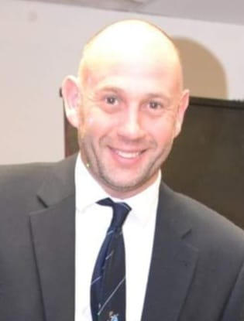
Telephone number: 011329447098 – 07904240569

Japan Karate Do
Welfare Officer Dr Alex Hamilton / Telephone number: 07846737425

Other Contacts

English Karate Federation ekf
Lead Safeguarding Officer - Steve Coupland https://www.englishkaratefederation.com/safeguarding

Local Authority Safeguarding

Cheshire West and Chester Safeguarding Children Partnership
Office hours: 0300 123 7047
8.30am – 5pm (Monday – Thursday)
8.30am – 4.30pm (Friday)
Out of hours: 01244 977 277
4.30pm – 8.30am (Monday – Thursday)
From 4pm (Friday)
24 hours weekends and bank holidays

Cheshire West and Chester Local Safeguarding Adults Board
0300 123 7034 (or out of hours: 01244 977277)
Ann Craft Trust
www.anncrafttrust.org
Email Ann_craft_Trust@nottingham.ac.uk
Telephone number 0119515400

NSPCC Email : help@nspcc.org.uk
Telephone number 0808800500

Cheshire Police : Telephone 101 request safeguarding unit

